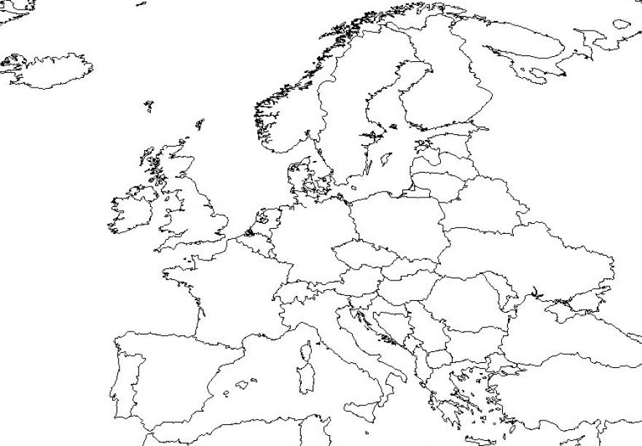
Label: France Britain Poland Allied Countries- Axis Controlled-
Italy Spain Austria
Germany Russia Czechoslovakia (Czech Republic+Slovakia) Axis Countries- Neutral-
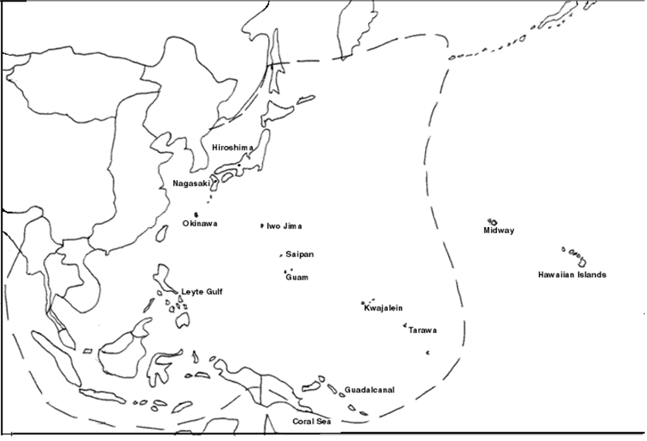
Label: Japan French Indochina Axis- Axis Controlled-
China Australia
Philippines Allies-
Korea

